LASER DERBY

User Manual

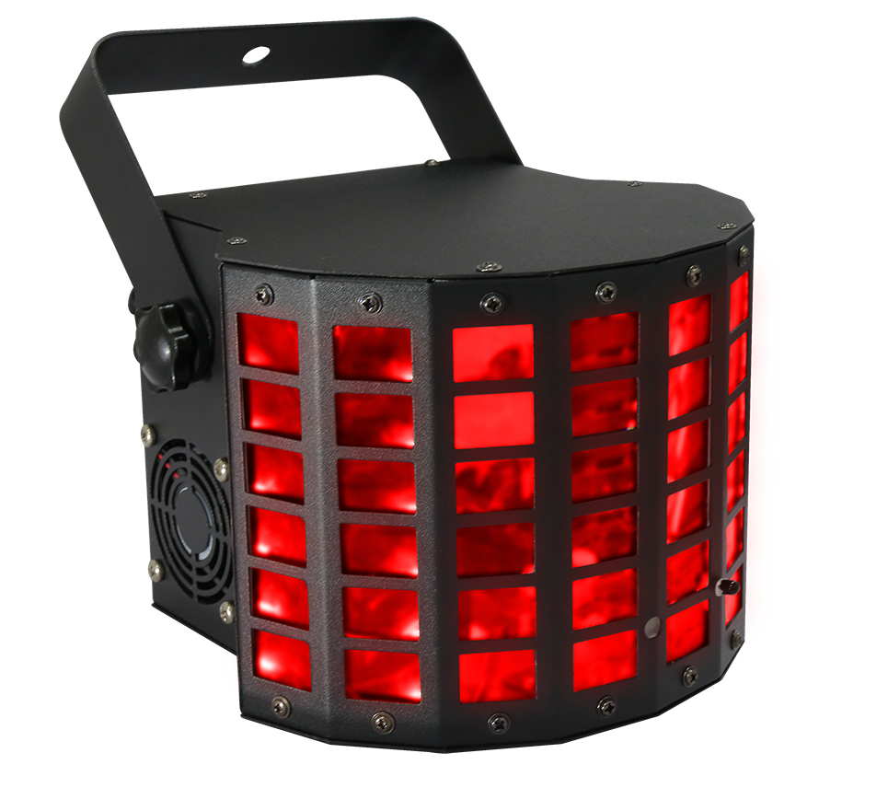

Please keep this manual for further use!

Contents

Introduction-----------------------------------------------------------------------------P2

Silkscreen on light--------------------------------------------------------------------P3

Safety instruction and product specification--------------------------------P4

Menu /DMX table ----------------------------------------------------------------------P5

Remote controller operation ----------------------------------------------------- P6

DMX512 connection and address setting------------------------------------ P7

Structure and installation --------------------------------------------------------P8

Maintenance, warranty card--------------------------------------------------------P9

Introduction

Thank you for purchasing our led butterfly light. Please read user guide for safety and operations before using. Keep this manual for future reference.

This unit has been tested at our factory before being shipped to you, there is no assembly required.

Once after received this product , please take and put carefully. And check cautiously that whether the product was damaged or not during the transportation.

Checking Parts
Please check if the following parts are included:
1 x Led Light
1 x User manual
1 x Power cable
1 x DMX signal cable

Caution
Before leaving the factory, this device has passed strict inspection, functions stable and perfect packing. If this device will be operated in any way different to the one described in this manual, the product may suffer damages and the guarantee becomes void. Furthermore, any other operation may lead to dangers like short circuit, burns, electric shock, crash etc. If any technology changes of this manual, company do not notice in further and have interpretation.



CAUTION!

Keep this device away from rain and moisture!

Unplug mains lead before opening the housing!

Warning!


Damages caused by the disregard of this user manual are not subject to warranty. The dealer will not accept liability for any resulting defects or problems.

Silkscreen on light

------------------------------------------------------------------------------CE compliant
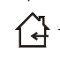

---------------------------------------------------------------------------Only indoor use



---------------------------------------------------------------------------RoHS Compliant

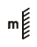

--------------------------The minimum distance from lighted objects(meter)

------------------------------------------------------------Max. Ambient Temp

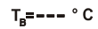
---------------------------------------------------------Max. Housing Temp


--------------------------------------------------------------------Safety warning


----------------------------------------------------------------------------Careful burns


----------------------------------------------------------------- -Careful electric shock

----Not suitable for directly installed on the surface of ordinary combustible materials

1.Safety Instructions
- Please open and check whether break or not for transport once receive this fixture, if yes, not use it and contact dealer or manufacture as soon as possible.
- The Max applicable temperature for the light is 40°C. Do not use the light under or above the temperature. ta=40℃
- The fixture is applicable for many occasions, it should keep clean, and avoid long use in overheating or dusty environment. To prevent the fixture from the chemical liquid .
- User must be careful of fire, heat, electric and fall-off that make heavy or fatal injury. Please read this user manual carefully before power on and installation, following safety and operation instruction in it. If still have any questions, please contact dealer or manufacture.
- User must following this user manual, do not open fixture by yourself, if any problems, please contact professional technician, maintenance should by technician.
Do not power on or start the fixture before installation, please stop after working more than 8 hours, which will longer use life.
- Fixed installation, do not by strong shocks.
- The minimum distance between light and the illuminated surface must be more than 1 meter. 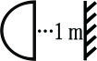

- Never look directly into the light source to avoid hurt to eyes (especially epileptics)!
- When dustproof glass at light output breaks, cracks or other visible damage, user should replace with new glass to continue to use.

2. Installation

- When install this equipment please make sure there's no flammable surfaces (decorated things, etc) and minimum distance of 0.5M from the equipment to the flammable.

- The installation of the effect has to be built and constructed in a way that it can hold 10 times the weight and without any harming deformation.
- The installation must always be secured with a secondary safety attachment, e.g. an appropriate safety rope.Never stand directly below the device when mounting, removing or servicing the fixture.

3. Specification
- 13 DMX channel；
- Control mode: DMX, Master/slave, Auto, Sound activated
- 3pin DMX input/output connector
- 1pc 30W 4in1 LED
- 1pc 150mW red laser diode +1pc 50mW green laser diode
- With interlock and safety switch at rear panel
- Power supply：AC100V-240V 50/60Hz；
- Power consumption：35W；
- MAX ambient temp:40℃；
- Max fixture surface temp：65℃；
- N.W：1.7KG G.W.：2KG
- Inner Packing(mm):：31*25*18cm
- Outer Packing(mm)：64*52*39cm(8pcs/carton）

- Panel display instruction

MENU
Addr(set DMX address)

1-512

SPXX (speed 0-99)
Shou(show mode)

Sh 1:only LED effect with speed adjustable)
Sh 2:only laser effect with speed adjustable 速度可调

SPXX (speed 0-99)
Ver

版本号)

Soun(sound mode)

Sh 3:LED+laser effect with speed adjustable
SPXX (speed 0-99)

Sh 4:LED+laser effect with fixed speed
Adjust MIC sensitivity on rear panel

Display Software version

TeNP

版本号)

Light temperature

5. DMX Channel Instruction

CH | Function | DMX value | details
CH1 | Red dimming | 0-255 | Red dimming
CH2 | Green dimming | 0-255 | Green dimming
CH3 | Blue dimming | 0-255 | Blue dimming
CH4 | white dimming | 0-255 | white dimming
CH5 | LED strobe control | 0-9 | No strobe
CH5 | LED strobe control | 10-255 | Strobe speed from slow to fast
CH6 | Master dimming | 0-255 | Master dimming
CH7 | Laser color control | 0-9 | OFF
CH7 | Laser color control | 10-127 | Red
CH7 | Laser color control | 128-199 | green
CH7 | Laser color control | 200-255 | Red+green
CH8 | Laser strobe control | 0-9 | No strobe
CH8 | Laser strobe control | 10-255 | Strobe speed from slow to fast
CH9 | LED motor control | 0-127 | Motor position option
CH9 | LED motor control | 128-255 | Motor speed from slow to fast
CH10 | Laser motor control | 0-127 | laser motor position option
CH10 | Laser motor control | 128-255 | laser motor speed from slow to fast
CH11 | Mode control | 0-9 | DMX mode
CH11 | Mode control | 10-100 | Show 1，Led (speed controlled by CH12)
CH11 | Mode control | 101-150 | Show 2，Laser (speed controlled CH12)
CH11 | Mode control | 151-200 | Show 3，Led+Laser(speed controlled by CH12)
CH11 | Mode control | 201-255 | Show 4，Led+Laser(at fixed speed)
CH12 | Show1,2,3 speed | 0-255 | From slow to fast
CH13 | Sound ON/OFF | 0-127 | Sound sensitivity OFF(for CH11)
CH13 | Sound ON/OFF | 128-255 | Sound sensitivity ON (for CH11)

6. Remote controller operation
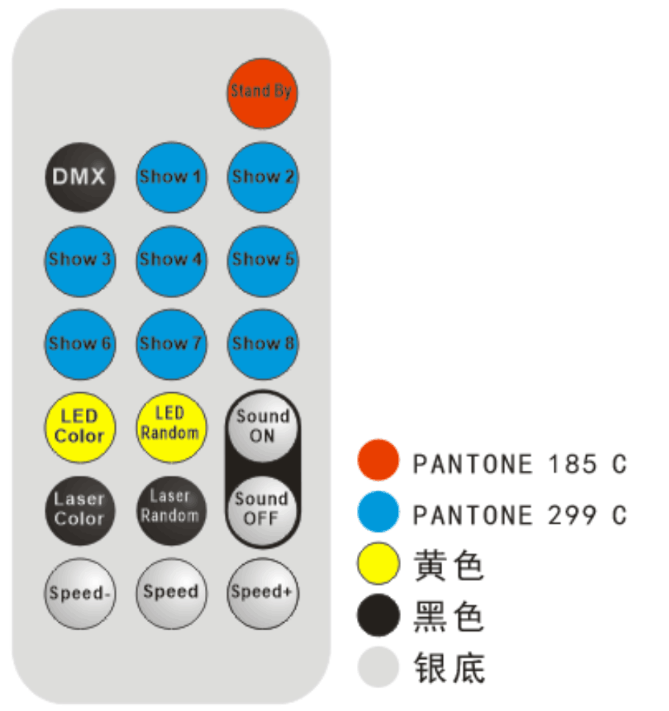
Yellow
Black
Silver

Functions:
1): StandBy ：Standby mode for whole light
2): DMX：enter DMX mode
3): Show 1: LED show with adjustable speed
4): Show 2： Laser show with adjustable speed
5): Show 3: LED +Laser show with adjustable speed
6): Show 4: LED +Laser show with fixed speed
Show 5-Show8 : no function
7):LED Color: choose LED color, 15 colors for option,
8):LED Random : LED with random color
9):Laser Color : choose laser color, 3 colors for option
10):Laser Random: Laser with random color
11):Sound ON,Sound OFF: sound switch，when choose Sound ON，Show 1-Show4 is for Sound show，when choose Sound OFF,Show 1-Show 4 is for auto show
12）:Speed- : decrease speed, Speed+: increase speed

7. DMX-512 connection

3-Pins DMX Out 3-Pins DMX In

(Female) (Male)
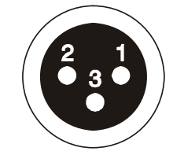


1 Earth 2 DMX- 3 DMX+

8CH for example
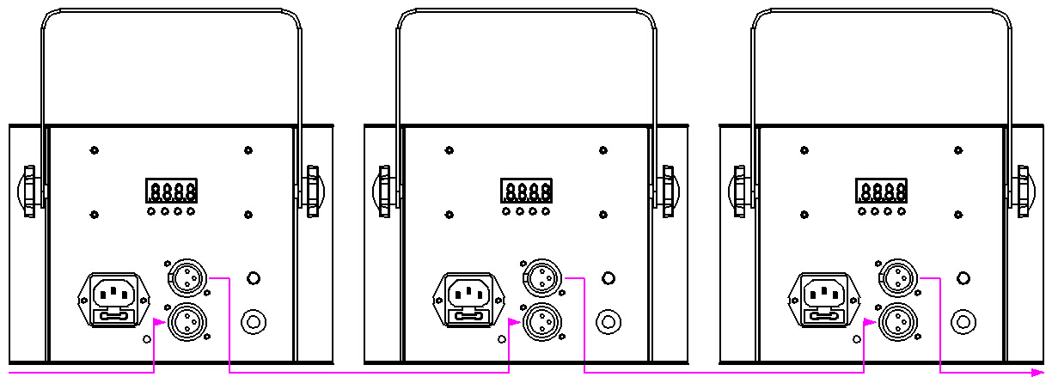

DMX input
DMX output
First（address 001） Second（address 009） Third（address 017）

8. DMX address setting

Each fixture must set a specific starting address. When receiving signal transmission, fixture will receive channel control signals which from the starting address.

According to different requirements or easy to use, the user can set many value fixtures to the same address, also can set up a separate address for every device.

If you set the same address,all the devices will receive from DMX channels signal. All connecting fixtures are jointly controlled, controller can't separate control a device.

If you set a different address, each device will be separate from its particular set the starting address and begin accepting DMX512 control signal, so that more convenient separate control one device.

Using this method must be based on channel quantity of device to determine a starting address.
This light has 13 channels. When you use 13CH, you should set the starting address of the first unit to 1, the second unit to 14(13+1), the third unit to 17 (4+13), and so on.

9. Installation

1 Clamp
2 Handle
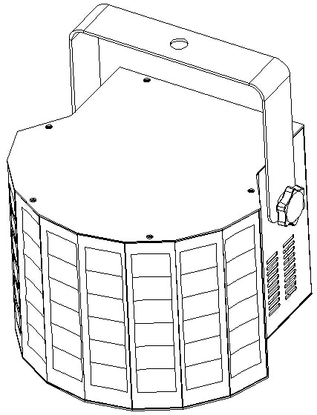

1. The light can work properly when the ambient temperature is -25~40℃, do not use the light when the ambient temperature is over 40℃ or under -25℃.
2. The installation has to be built and constructed in a proper way that the rigging can hold 10 times of the light weight .
3. Don't stand under the light when installing, disassembleing, repairing or maintaining the light.
4. Please use safety chain to ensure good installation.
5. Fix the M8 screw of the hook clamp in ￠12.5mm hole of the light handle.

10. Dimension
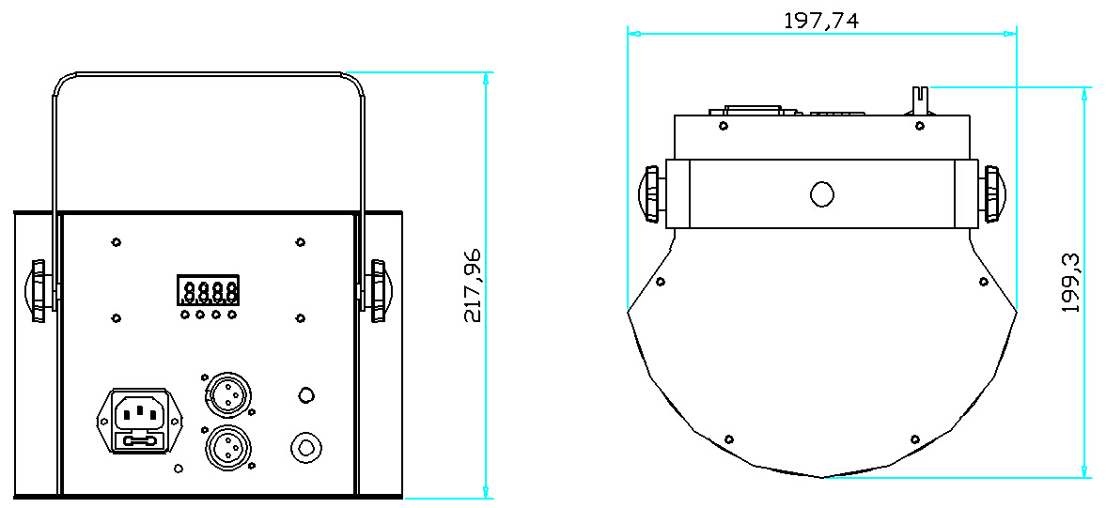

11. Cleaning and maintenance

Cleaning should be performed every 15-day period, by using a sponge which is dipped with alcohol, rather than wet cloth or other chemical liquid, to clean the mirror.
Turn off power before cleaning and maintenance!
CAUTION

Warning
Do not see directly light source when open the light, and make sure power off before do any installation or maintenance.


 Wires connection must be professional person!
CAUTION

Warranty Card
This product is made of high-brightness transistor. We will provide 1 year warranty under the condition that user has operated the light normally and lifetime service. We won't provide warranty if the damage is caused by artificial or force majeure event. Cost of fittings should be charged by user if product need maintenance after 1 year .Please cut this warranty card and shipped it along with the product to our factory when applying for warranty.
Product： Purchasing date： Code of invoice：
Warranty date: From To
User’s name： Add：
Company： Tel：

